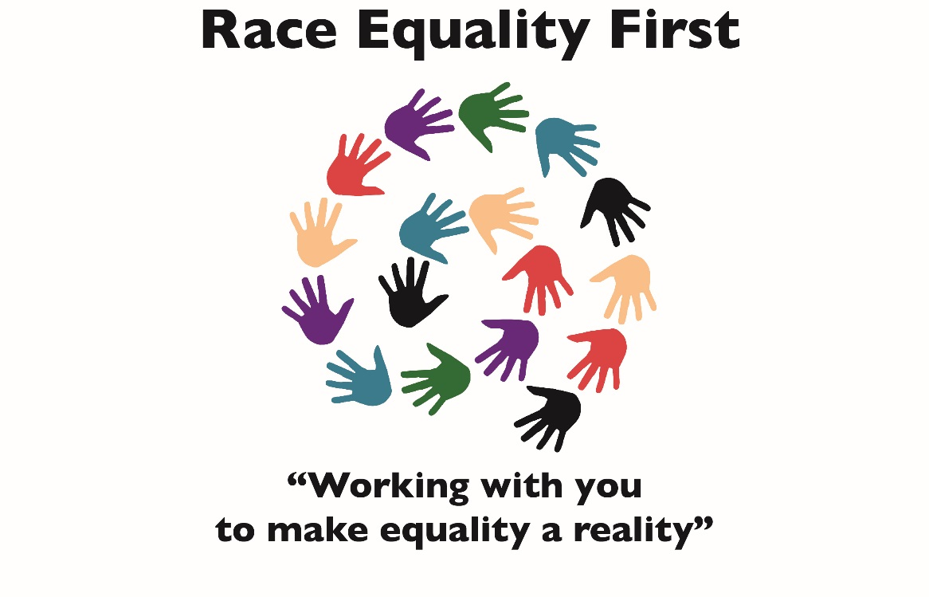

Privacy Policy

Privacy Policy

We have updated this policy to reflect changes in data protection law. This policy is effective from 25 May 2018.

At Race Equality First, we are committed to protecting and respecting your privacy.
This policy explains when and why we collect personal information about you, how we use it, the conditions under which we may disclose it to others, how we keep it safe and secure and your rights and choices in relation to your information.

Any questions regarding this policy and our privacy practices should be sent by email to info@raceequalityfirst.org.uk or by calling us on 029 2048 6207.

What type of information is collected from you?
The personal information we collect, store and use might include:
- your name and contact details (including postal address, email address and telephone number);
- your date of birth;
- information about your activities on our website and about the device used to access it, for instance your IP address and geographical location;
- any other personal information shared with us.

Data protection laws recognise certain categories of personal information as sensitive and therefore requiring greater protection, for example information about your health, ethnicity and religion.

We do not usually collect sensitive data about you unless there is a clear and valid reason for doing so and data protection laws allow us to. For example, we may ask for more details about your work or background if you are a victim of hate or discrimination.

Where appropriate, we will make it clear why we are collecting this type of information and what it will be used for.

How and why is your information used?
We may use your information for a number of different purposes, which may include:
- Providing you with information, advocacy, advice or support you have asked for. This may be because you have been a victim of hate or discrimination or because you want to access other services or activities we deliver.
- Carrying out our obligations under any contracts entered into between you and us;
- Keeping a record of your relationship with us;
- Conducting analysis and research to better understand how we can improve our services, projects or information;
- Checking for updated contact details against third party sources so we can stay in touch if you move (see the section on ‘Keeping your information up to date’ below);
- Seeking your views or comments on the services we provide;
- notifying you of changes to our services;
- Sending you communications which you have requested and that may be of interest to you. These may include information about campaigns, fundraising appeals and activities and promotions of projects and services; and
- Processing grant or job applications.

How long is your information kept?
We keep your information for no longer than is necessary for the purposes it was collected for. The length of time we retain your personal information for is determined by operational and legal considerations. For example, we are legally required to hold some types of information to fulfil our statutory and regulatory obligations (e.g. casework/tribunals/health/safety and tax/accounting purposes).

We review our retention periods on a regular basis.

Who has access to your information?
We do not sell or rent your information to third parties. We do not share your information with third parties for marketing purposes.

However, we may disclose your information to third parties in order to achieve the other purposes set out in this policy. These third parties may include:

- Project Funders;
- Magistrates (Tribunal) / Crown Court (if you are a victim of hate crime or have an employment discrimination case for example);
- Service providers;
- Suppliers;
- Subcontractors and
- Other associated organisations for the purposes of completing tasks and providing services to you on our behalf (for example to process donations and send you mailings).

However, when we use these third parties, we disclose only the personal information that is necessary to deliver the services and we have a contract in place that requires them to keep your information secure and prevents them from using it for their own direct marketing purposes. Please be reassured that we will not release your information to third parties for them to use for their own direct marketing purposes, unless you have requested us to do so, or we are required to do so by law, for example, by a court order or for the purposes of prevention of fraud or other crime.

Lawful Processing
Data protection law requires us to rely on one or more lawful grounds to process your personal information. We consider the following grounds to be relevant:

Specific Content - Where you have provided specific consent to us using your personal information in a certain way, such as to send you information by email, text or telephone.

Performance of a Contract - Where we are entering into a contract with you or performing our obligations under a contract with our funders (monitoring reports for example).

Legal Obligation - Where necessary so that we can comply with a legal or regulatory obligation to which we are subject, for example where we are ordered by a court or regulatory authority like Crown Court, Magistrates, the Charity Commission or Fundraising Regulator.

Vital Interests - Where it is necessary to protect life or health (for example in the case of medical emergency suffered by an individual at one of our events) or a safeguarding issue which requires us to share your information with the emergency services.

Fundraising and Marketing Communications
We may use your contact details to provide you with information about the vital work we do for diverse communities living in Wales, our fundraising appeals and opportunities to support us, as well as the projects and services you can access, if we think they may be of interest to you.

Email/text/Phone
We will only send you marketing and fundraising communications by email, text and telephone if you have explicitly provided your prior consent. You may opt out of our marketing communications at any time by selecting the box in our registration forms to or by telling us by email, phone or text to stop our marketing emails.

Post
We may send you marketing and fundraising communications by post unless you have told us that you would prefer not to hear from us.

Your choices
You have a choice about whether or not you wish to receive information from us. If you do not want to receive direct marketing communications from us about our work and projects, then you can select your choices by ticking the relevant boxes situated on the form used to collect your information.

We’re committed to putting you in control of your data so you’re free to change your marketing preferences (including to tell us that you don’t want to be contacted for marketing purposes) at any time using: info@raceequalityfirst.org.uk, or by telephone on 029 2048 6207.

We will not use your personal information for marketing purposes if you have indicated that you do not wish to be contacted and will retain your details on a suppression list to help ensure that we do not continue to contact you. However, we may still need to contact you for administrative purposes like where we are processing a donation or thanking you for your participation in a project or event.

Your Rights
Under UK data protection law, you have certain rights over the personal information that we hold about you. Here is a summary of the rights that we think apply:
Rights of Access - You have a right to request access to the personal data that we hold about you. You also have the right to request a copy of the information we hold about you, and we will provide you with this unless legal exceptions apply. If you want to access your information, please send a description of the information you would like to see and proof of your identity by post to the address provided below.

Rights to have Inaccurate Personal Information Corrected - You have the right to have inaccurate or incomplete information we hold about you corrected. The accuracy of your information is important to us so we are working on ways to make it easier for you to review and correct the information that we hold about you. In the meantime, if you change email address, or if you believe any of the other information we hold is inaccurate or out of date, please contact us via email or telephone.

Right to Restrict Use - You have a right to ask us to restrict the processing of some or all of your personal information if there is a disagreement about its accuracy, or we are not lawfully allowed to use it.

Right of Erasure - You may ask us to delete some or all of your personal information and in certain cases, and subject to certain exceptions; we will do so as far as we are required to. In many cases, we will anonymise that information, rather than delete it.

If you want to exercise any of the above rights, please email us at info@raceequalityfirst.org.uk or call us on 029 2048 6207. We may be required to ask for further information and/or evidence of identity. We will endeavour to respond fully to all requests within one month of receipt of your request, however if we are unable to do so we will contact you with reasons for the delay.

Please note that exceptions apply to a number of these rights, and not all rights will be applicable in all circumstances. For more details we recommend you consult the guidance published by the UK’s Information Commissioner’s Office.

Keeping your information safe
When you give us personal information, we take steps to ensure that appropriate technical and organisational controls are in place to protect it.

Non-sensitive details (your email address etc.) are transmitted normally over the internet, and this can never be guaranteed to be 100% secure. As a result, while we strive to protect your personal information, we cannot guarantee the security of any information you transmit to us, and you do so at your own risk. Once we receive your information, we make our best effort to ensure its security on our systems.

Links to other websites
Our website may contain links to other websites run by other organisations. This policy applies only to our website‚ so we encourage you to read the privacy statements on the other websites you visit. We cannot be responsible for the privacy policies and practices of other websites even if you access those using links from our website.

In addition, if you linked to our website from a third party site, we cannot be responsible for the privacy policies and practices of the owners and operators of that third party site and recommend that you check the privacy policy of that third party site.

16 or Under
We are concerned to protect the privacy of children aged 16 or under. If you are aged 16 or under‚ please get your parent/guardian's permission beforehand whenever you provide us with personal information.

Vulnerable circumstances
We are committed to protecting vulnerable supporters, customers and volunteers, and appreciate that additional care may be needed when we use their personal information. In recognition of this, we observe good practice guidelines in our interactions with vulnerable people.

Transferring your information outside of Europe
As part of the services offered to you through this website, the information which you provide to us may be transferred to countries outside the European Economic Area (“EEA”). By way of example, this may happen if any of our servers are from time to time located in a country outside of the EEA. You should be aware that these countries may not have similar data protection laws to the UK. By submitting your personal data, you’re agreeing to this transfer, storing or processing. If we transfer your information outside of the EEA in this way, we will take steps to ensure that appropriate security measures are taken with the aim of ensuring that your privacy rights continue to be protected as outlined in this policy.

If you use our services while you are outside the EEA, your information may be transferred outside the EEA in order to provide you with those services.
We undertake regular reviews of who has access to information that we hold to ensure that your info is only accessible by appropriately trained staff, volunteers and contractors.

Website recording
Our website may also use the SessionCam website recording service. SessionCam is a product that has been developed by ServiceTick Ltd. SessionCam may record mouse clicks, mouse movements, page scrolling and any text keyed into website forms. The information collected does not include bank details or any sensitive personal data. Data collected by SessionCam from the ServiceTick website is for Race Equality First’s internal use only. The information collected is used to improve our website usability and is stored and used for aggregated and statistical reporting.

Review of this Policy
We keep this policy under regular review. This policy was last updated in April 2019.

We request that our Staff, Volunteers, Members and Visitors respect this Policy, a copy of which will be available on demand.

Approved by the Board of Directors of Race Equality First on 4 April 2019

