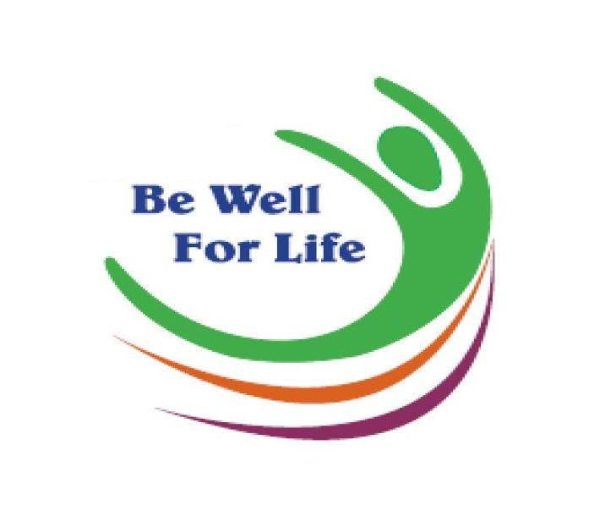
2018
Health Fair
MINORITY ETHNIC COMMUNITIES ANNUAL

EVENT REPORT

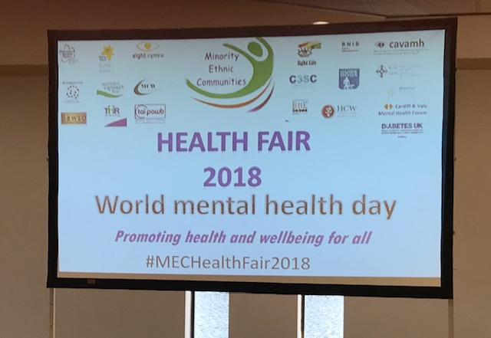

World Mental Health Day

- Introduction

On 10th October 2018 the eighth Minority Ethnic Communities (MEC) Health Fair was held. Vaughan Gething, the Cabinet Secretary for Health and Social Services opened this year’s Health Fair, along with Christian Malcolm, former Olympian, and Councillor Ramesh Patel, who all delivered speeches about the importance of mental health and well-being. They also took the time to visit many stalls engaging with the stall holders, visitors and volunteers. More than 400 visitors, including stall holders and volunteers attended the event.

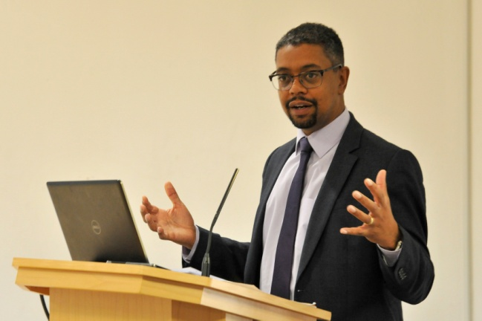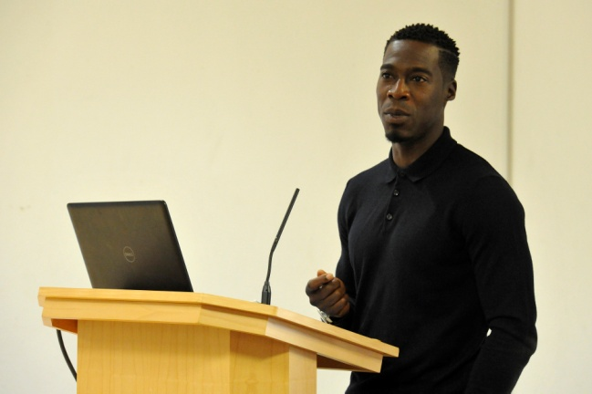

This successful event is now in its eighth year and in 2018 it was organised by a planning committee comprising of representatives from Cardiff and Vale University Health Board, Sight Cymru, Cardiff Third Sector Council (C3SC), Public Health, BAWSO, Marie Curie, The Mentor Ring, Diverse Cymru, Women’s Connect First, Alzheimer’s Society, Diabetes UK and NEXUS. Financial support for the event was generously provided by Sight Cymru, Marie Curie and the Alzheimer’s Society.

Some of the representatives, of this successful collaboration, are illustrated in the photograph below.

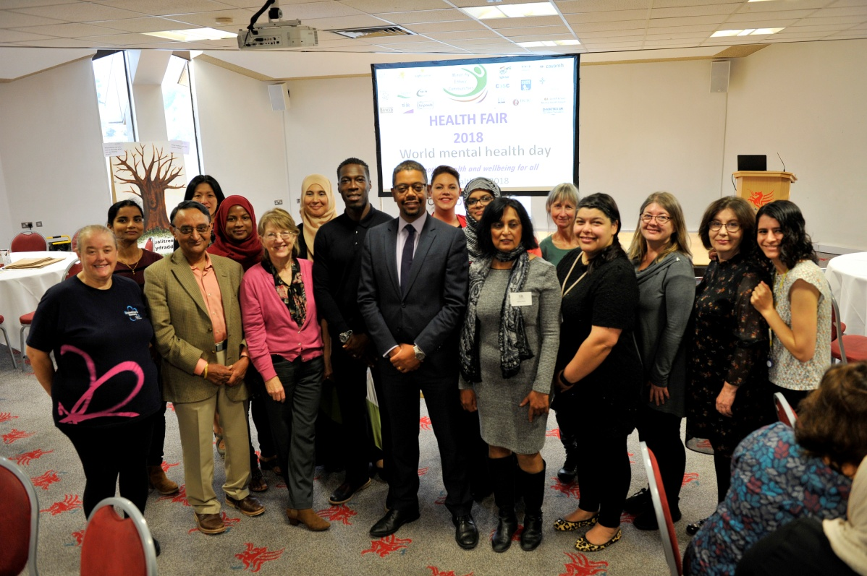

The purpose of the Health Fair has, from its inception, been to help individuals from different ethnic backgrounds become more aware of their own health needs and to enable health providers to improve their understanding of community health issues.
BME Communities and Mental Health and Well-being
This year the planning committee decided that the Health Fair should have a focus. In previous years it had been noted that the amount of stalls and information could be overwhelming, and some of the health messages were contradicting each other. Discussions took place around what theme this year’s Health Fair would have and it was decided to focus on Mental Health, therefore the event was held on World Mental Health Day.
The prevalence of mental health conditions within the BME Communities is higher than the average. There is also evidence to show that their experience of Mental Health Services is poor. Therefore the aim of this year’s Health Fair was to try and get communities to understand mental health conditions, how they can look after their mental health and well-being, what services are there to support them if they should need them, and also reduce the stigma around mental health conditions.
The planning committee ensured that all stalls had a link to promoting mental health and well-being or were able to support people and families who had a mental health diagnosis. They committee also reached out to local community groups to run workshops on subjects such as mindfulness, art therapy and stress management.
2. Attendance Report

The registration desk was situated on the entrance to the event and the volunteers kindly undertook the meet and greet role. Visitors were asked to formally register and given a programme of the day along with a map clearly marking out where watch of the stalls and break out rooms were.

Approximately 405 visitors attended the event, however some stall holders had signed in on the visitors sign in sheet so numbers can only be reported as approximates. The majority of attendees who had disclosed their area of residence were predominately from the Grangetown, Butetown and Riverside areas. This could have been influenced by the location of the events venue. 15% of visitors were attending from a variety of other places, outside of Cardiff and the Vale of Glamorgan, which included; Newport, Swansea and Bridgend.

This year there was a lot of engagement from community groups such as the ESOL class and students from the local college. This meant that there was a more diverse age range and a slight increase on male visitors to the event.
There were three different evaluation forms completed;

- One for the attendees 150 completed
- One for the stallholders 22 completed
- One for the volunteers 10 completed

The analysis of these evaluations is illustrated within the body of this report.
3. Health Checks and Advice

3.1 Health Checks Offered

Taking into account advice from Health Professionals it was decided this year that blood testing would not take place at the event. The focus instead was to encourage visitors to engage with Primary Care Services and Preventative Health Screening. It is widely recognised that a large proportion of people from Black and ethnic minority communities are not registered with a local GP and numbers who attend preventative health screening are low. Therefore, it was felt that the aim of this year’s Health Fair should be to raise a wider awareness of these issues.

The health checks on offer were:
- Blood pressure
- Diabetes Risk Assessments which included
  - Height
  - Weight
  - Body Mass Index (BMI)

  - Blood Pressure Checks

The Stroke Association were present at the Health Fair and undertook blood pressure checks. Current evidence suggests high blood pressure and ethnicity are both risk factors of stroke. Coupled with the fact that around one in ten adults are recorded as having high blood pressure, it was agreed that important form of health screening, needed to be included at the fair
The team undertook 85 Blood pressures checks on visitors aged between 18 and 85 years old. The checks resulted in a fifth of those screened being advised to follow up with their results with their own GP.

  - Diabetes Risk Assessment

Diabetes UK state that people from minority ethnic communities are up to six times more likely to develop the condition. In a bid to raise awareness of the condition amongst the BME community they undertook risk assessments to identity if a person is at low, moderate, or high risk of developing diabetes. The seven questions are related to age, gender, waist circumference, BMI, ethnic background, blood pressure and family history. Based on scores from the assessment appropriate advice is provided in the form of lifestyle changes or a GP referral.
On the day the team undertook diabetes risk assessments on 70 visitors, of these 31 were advised to speak to their own GP about the results.
The health checks proved popular with the visitors and lifestyle advice was offered at by each of the organisations based on the results from each individual health check, e.g. healthy eating and physical activity. Where it was considered necessary, attendees were advised to visit their GP.
- Stalls
This year the decision was made by the steering group to streamline the amount of stalls at the event. In previous years it was felt that the amount of stalls was over whelming and visitors were not getting the full benefit of the information, as they wanted to get around to all the stalls. Concerns had also been raise that sometimes they were not even related to health and well-being in anyway. This year organisations were asked to submit an application of interest, advising them of the theme of the event, and that originations relating to this theme would be given prior consideration.

The event hosted 35 organisations and initiatives with stalls all relating to Mental Health and Well-being. As in previous years the stall proved very popular and provided the attendees with a range of useful information. A full list of stallholders can be found in the appendices highlighting the range of organisations who support the event.

4.1 Stallholder Feedback

On the day 22 of the organisations who attended this year’s event completed an evaluation form providing feedback following the event. The majority of comments received stallholders reported that this year’s event had been an excellent opportunity for community engagement and networking with other organisations. However, it was noted that some felt the speeches at the opening of the event went on too long and those in the same room were unable to engage fully with visitors at their stalls as they didn’t want to disturb the speakers.

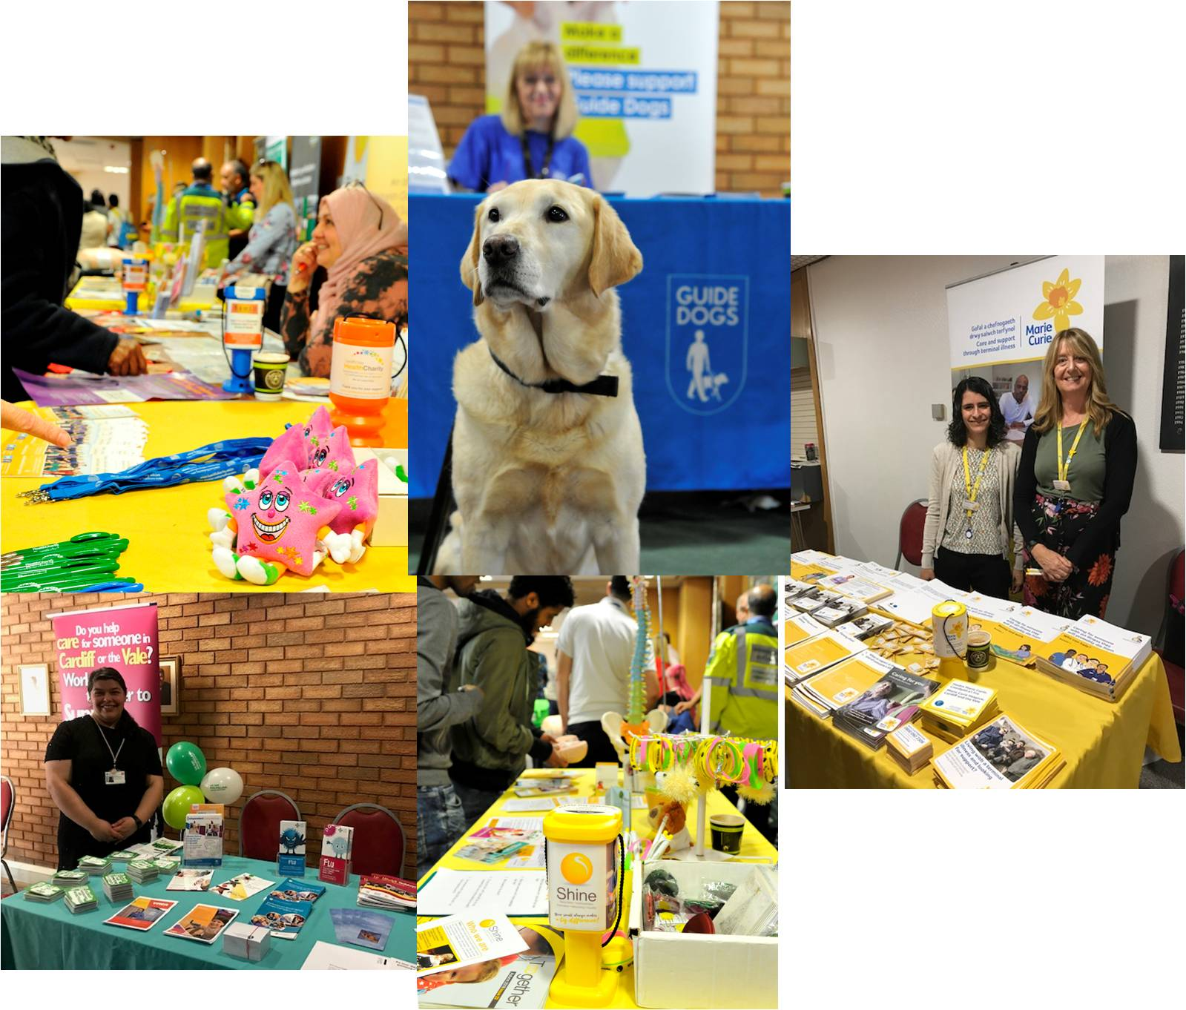

Has this year’s Health Fair helped you engage with minority ethnic individuals/ communities?
When asked if they felt that the Health Fair had helped them engage with ethnic minority communities 76% said that yes it had helped them. Some stallholders were unsure of the impact with 24% stating that it was too early to tell if the event had helped with engagement.

Do you think the Health Fair will improve future engagement with minority ethnic communities?
The majority of the stall holders (81%) felt that the Health Fair would improve future engagement with ethnic minority communities. Only 14% of the stallholders stated that it was too early to know if the Health Fair would impact on future engagement.

Are there any organisations or interest groups with whom you have discussed future activities?
As in previous years, stallholders who attend the event find the opportunity to network with other organisations extremely valuable. This was once again evident in the evaluation forms with 76% of stallholders stating that they had discussed working together with other organisations in the future.
Comments
The majority of the qualitative data, collected on the stallholder evaluation forms, was very positive about the event. The organisations saw the benefit of the Health Fair and thought it was a well organised event. However, it was noted that the speeches were too long and that he PA system was not very good, which meant those at the back of the room were unable to hear them. It was suggested that the layout at future events should be considered more carefully.

Difficult to have stalls in the same area as the guest speakers as the natural hub of conversation made it difficult to hear speakers and for stall holders to talk with visitors.
Great opportunity

A very well organised event, however, the sound system was weak and I couldn’t hear the speakers.

Good to network, good contacts made. It has been a great opportunity to promote services.

The event was fantastic, really enjoyed it.

This event has allowed for us to meet groups and promote projects and activities being run, allowing people to be aware of what we have on offer in their communities.

- Presentations

Top Tips for Improving Mindfulness
Helen Tilley (Marie Curie)
Folic Acid are you Getting Enough?
Helen Allen (SHINE Cymru)
Bereavement and Mental Health
Ahmed Alsisi Chaplain Director of Acceptance
Housing and Mental Health: Do you know your Rights?
Sarah Vining (Tai Pawb)
Stress Control
Sarah Sweeney (Diverse Cymru & Primary Mental Health Service)
Mental Health in Children
Sunil Pulapaka (Child and Adolescent Psychiatry Consultant Cwm Taff NHS Trust)

A number of health professionals attended the Health Fair to deliver talks and presentations on a variety of issues that related directly to Mental Health. Attendance at the talks was varied with some better that others; this may have been down to the opening speeches over running and the difficulty some found in locating the room.
Not many people turned up to the Expert Presentation because they were all in the main room. Perhaps think of better sign posting and signage for people. Presenter

5.1 Evaluation
This year in order to gain some relevant feedback from visitors who attended the Expert Presentations a flipchart stand and coloured stickers were placed at the entrance of the room. Each presentation had their own evaluation sheet that was placed on the flip chart, and on leaving the presentation visitors were asked to rate the presentation with a coloured sticker. They also had the opportunity to write their comments on a post-it and place on the sheet. The sheets were then to be collected and replaced at the end of every session. Unfortunately none of the evaluation sheets were completed, this has meant no evaluation of the Expert Presentations can take place.
- Taster Sessions
Three taster sessions were held during the Fair and were activities that encouraged participants to look after their Mental Well-being. The sessions were open to all and each lasted forty five minutes, most of which were well attended.

Mental Health and Well-being
Linda Newton (Cardiff and Vale Mental Health Forum BME Group & CAVAMH)
Singing
Keith Murre
Arts and Crafts
Rehana Nadeem
Laughter Therapy
Sian Roach
Mindfulness
Roz Grimble

6.1 Evaluation
As with the Expert Presentations visitors who attended Taster Sessions were asked to rate the presentation with a coloured sticker on a flip chart and given the opportunity to write their comments on a post-it and place on the sheet. Similar to the Expert Presentations, the sheets were then to be collected and replaced at the end of every session. Unfortunately none of the evaluation sheets were completed, this has meant no evaluation of the Taster Sessions can take place.

9. Visitor Evaluations

9.1 Evaluation Forms

Evaluation forms were made available on the day for attendees to complete. In total 150 evaluation forms were returned, which was approximately a 37% response rate. In addition, this year, there was an opportunity for visitors to feedback throughout the day at one of the five evaluation stands located throughout the venue.

The information from the analysis is shown below together with a sample of the observations made.

Although a high percentage of visitors completed the evaluation form it is important to note that the results shown below may not be representative of the attendees of the event as a whole.

Have you attended any previous Health Fairs?

When asked if they had attended a MEC Health Fair in previous years 59.5% of the respondents said that they had not. It is positive that the event is still reaching new people in its 8th Year. In addition 76.5% of respondents said that they would recommend the event to family and friends.

Is there anything you would change about the event?

The attendees were given the opportunity to sate whether or not there was anything about the event they would change, and if so what. A high percentage of respondents (41.5%) stated that there would be things they would change about the event. When looking at what they would change the majority commented that there were too many speakers opening the event and the PA system was not loud enough. A few also commented that they would have liked to have seen the information in a larger variety of languages.

Comments
Do not put stalls in the same room as speakers. Couldn’t hear them and it felt very disrespectful.
No, it was great
It was informative, great

Could we have registration forms prior to the event to save time in registering large groups.
A good PA system, I could not hear half the time as people were talking during the opening address.

Are you going to make any changes to your lifestyle after today’s event?

A large proportion of people, 73%, said that they would or would possibly make some lifestyle changes. Healthy eating, such as eating more fruit and more exercise where the lifestyle areas that visitors said they would change. One even commented that they would be attending their own GP surgery after undertaking a diabetes risk assessment.

Comments

Think positively and help to change thoughts of the young in family and community
I attended a lecture on stress management which made me think differently

Look after myself health wise
I will try and look after my health, diet and do more exercise

9.2 Evaluation Tables Feedback

In addition to the evaluation forms this year it was decided to have Evaluation stations throughout the event. This decision was made to try and make the main evaluation form smaller, as it was felt the response rate may improve if the evaluation forms were kept to one side of A4. Each of the stations had large flipchart sheets and visitors were asked to rate elements of the event as excellent, ok or poor. Post-it notes were also left at the tables for any comments they would like to leave.

The response rates on the evaluation stands were low in relation to the number of visitors. This could have been due to the fact that no one was overseeing the areas, so there was no one to explain to visitors what was expected.

The results are below and as with the evaluation forms it is important to note that the results shown below may not be representative of the attendees of the event as a whole.

Overall Event (18 Responses)

89% gave the overall event an excellent rating

Venue (22 Responses)

86% said that the Venue was excellent

Refreshments (17 Responses)

88% rated the refreshments as excellent

Transport (16 Responses)

75% said that the transport facility was excellent

Stalls (17 Responses)

59% gave the stalls an excellent rating

Health Checks (13 Responses)

85% rated the health checks as excellent

Comments

More translators available please
Translators for beginners of English

More information about sports. The majority of the audience are ESOL learners. Please give more thought to basic English learners. A lot of the info and speakers were too complicated.
Fab, very informative, Super friendly staff.

Can the Dentist/GPs come back? Can reception be briefed on key stalls and events. They did not know the dentist wasn’t here.

10. Volunteer Involvement and Feedback

12 volunteers attended the Health Fair and carried out a variety of roles. Feedback from pervious Health Fairs in addition to interpreting and language support, this year, the volunteers were given specific roles such as:

- meet and greet,
- general signposting,
- registration,
- supporting the expert talks and taster sessions
- supporting visitors complete their evaluation form.
Volunteers were clearly identifiable by wearing yellow sashes. They spoke a wide range of languages including German, Bangla, Guajarati, Hindi and Urdu.
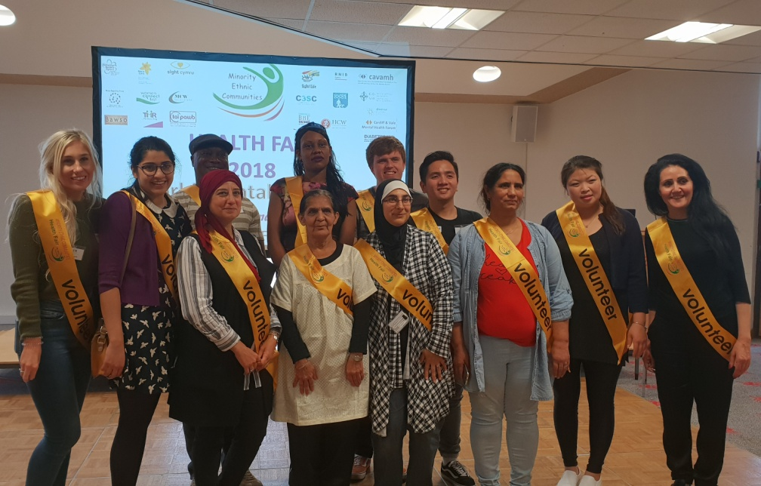
All volunteers attended an induction session prior to the event ensuring they were clear about the roles assigned to them. In addition to their assigned tasks, many helped out in other ways at short notice, displaying great teamwork.

10 volunteers completed evaluation forms. The results are summarised below:
10.1 Volunteer Feedback

Languages skills utilised;

Most of the volunteers reported helping with interpretation on the day utilising their language skills in languages such as Urdu, Bangla and Guajarati.

Did you feel you had relevant training, before the event, to undertake the role?

All the volunteers stated they had received enough training, before the event, to undertake the roles they had been assigned.
What did you enjoy most and least about the role?

Volunteers were asked what they enjoyed and what they didn’t enjoy about the roles they undertook.
Being able to talk to people about our organisation.
Being able to practice my English

Communication and learning new things

How can we improve?
When asked how we could improve the event, the main response was with regards to ensuring the introductions were more streamline and that a better sound system is in place. One other suggestion was better signage around the venue and more printed maps to give to visitors.
11. Conclusion

Over all this years’ Ethnic Minority Health Fair was very successful, attracting members from Ethnic Minority Communities that had never attended the event before. New methods of evaluation were tried with some being more successful than others. A number of learning points can be taken forward to inform the planning of the 2019 Ethnic Minority Health Fair. Recommendations for the Planning Group can be found in section 12.

12. Recommendations (in alphabetical order)

Evaluation

New methods of evaluation were trialled this year and although the shorter format of the evaluation form did improve the response rate, the other forms of evaluation had poor response rates. Consideration needs to be given to having volunteers stationed at the tables and entrances to the Presentations and Workshops. The volunteers could hand out the stickers and encourage participants to help improve future health fairs by providing their evaluation/comments.

Gender and Age

Although this year we had a higher number of males and a more varied age range, it is important to ensure the planning group consider ways to increase the number of male visitors and engage with the younger population.

Marketing and Publicity Strategy

The marketing strategy for 2019 should take account of:

- The fact that the majority of visitors found out about the event though word of mouth.
- Strengthening engagement with the Asylum Seeker services and the travelling community along with the charities who provide support to them. The aim being to raise awareness of support services and to improve service user engagement.
Opening of Event
This year both visitors and Stallholders commented that the opening speeches were too long. The planning group will need to consider how to ensure organisations who have funded the event get a platform to showcase their work. It could be suggested that information about the organisations, which have funded the event, is given to visitors on registration.

Translation

This year we had a number of comments with regards to the lack of translated information. It was also highlighted that a number of the visitors were only beginning to learn English and the information being provided was too complex. Consideration needs to be made to ensure speakers are not using jargon and keeping their messages simple, encourage organisations to produce Easy Read and/or translated materials.

Venue and layout

The Health Fair was hosted by County Hall this year and although all the stalls, workshops and presentations were on one level some did comment on the access to the venue. Visitors had to come down stairs to enter the event; the lift was behind a staff restricted reception area and not offered as a means to get to the event.

Some visitors also mentioned that it was difficult to find the room where the expert presentations were being held, as it was not clearly signposted. Consideration needs to be given to accessibility and way finding for 2019.

12. Acknowledgements
The 2018 MEC Health Fair would not have been possible without the hard work and commitment from members of the planning committee and the financial support of the following organisations:
Partners
Cardiff and Vale University Health Board
Diabetes UK
C3SC
Diverse Cymru
The Mentor Ring
BAWSO
CAVAMH
Cardiff and Vale Mental Health Forum
Sport Cymru
Sponsors
Alzheimer Society
Marie Curie
Sight Life
RNIB Cymru
Guide Dogs
Women Connect First
Tai Pawb
Race Equalities First

